**Tribhuvan University**

**Faculty of Humanities and Social Sciences**

**Trekking Equipment E-Commerce Web Application**

**A PROJECT REPORT**

**Submitted to**

**Department of Computer Application**

**Janamaitri Multiple Campus**

**In partial fulfillment of the requirements for the Bachelors in Computer Application**

Submitted by

**Siddhartha Shakya**

**Laxmi Thami**

Under the Supervision of

**Kamal Tamrakar**

Contents

Proposal for Trekking Equipment E-Commerce Website 3

1. Introduction 3

2. Problem Statement 3

3. Our Solution 3

4. Objectives 4

i. Local Product Showcase: 4

ii. Customizable Packages: 4

iii. Technology Stack: 4

5. Methodology 4

i. Study of existing system 4

ii. Requirement Collection 4

6. Technical Feasibility 5

7. Operational Feasibility 6

8. Economic Feasibility 6

9. High-level Design of System (System Flow Chart/ Methodology of the proposed system/ Working mechanism of proposed system) 7

User Function 8

Admin Function 8

Methodology of the proposed system 9

Working Mechanism of Proposed System 10

10. Gantt chart 11

Expected Outcome 11

11. Reference 12

# Proposal for Trekking Equipment E-Commerce Website

## Introduction

This proposal outlines the development of a unique e-commerce website catering to the booming trekking market in Nepal. Leveraging Nepal's unparalleled trekking landscape and rich cultural heritage, the website will offer a one-stop destination for adventurous travelers seeking a curated selection of trekking gear, personalized recommendations, and local expertise. By using CRUD, we will achieve Following functionality.

* **Users**: Registering accounts, viewing variety of products as well as make online payment.
* **Products**: Adding new gear, apparel, and resources to the website inventory.
* **Reviews** and Ratings: Allowing users to share feedback on products and experiences.

## Problem Statement

Nepal boasts some of the world's most awe-inspiring treks, from the legendary Everest Base Camp to the mystical Annapurna Circuit. Yet, trekkers often face challenges finding reliable information, accessing suitable gear, and connecting with authentic local experiences. Existing platforms lack specialization in Nepal and fail to capture the essence of its distinct trekking culture.

## Our Solution

**Curated Gear Selection:** Partnering with local Nepali brands and renowned international manufacturers, we will offer a carefully chosen inventory of trekking gear designed specifically for Nepal's diverse terrains and weather conditions.

**Personalized Recommendations:** An interactive platform will guide users through a selection process based on their experience, trekking goals, and budget, recommending ideal gear combinations and local guides.

**Cultural Immersion**: Dedicated sections will showcase cultural experiences, homestays, and locally run businesses, encouraging responsible tourism and supporting local communities.

## Objectives

The primary objectives of developing the Trekking Equipment E-Commerce Website are as follows:

### Local Product Showcase:

Highlight Nepali-made trekking gear, clothing, and accessories to promote local businesses. Provide a platform for local artisans to showcase traditional craftsmanship.

### Customizable Packages:

Allow users to create and customize their trekking gear packages based on their preferences and specific trekking routes.

### Technology Stack:

Our proposed technology stack will be chosen to provide a scalable and secure platform, considering the unique needs of the Nepali market:

## Methodology

To guarantee a reliable, effective, and user-friendly solution, we will commit to a thorough process when developing the web application for trekking equipment. The approach covers a range of phases, from preliminary planning to implementation, to cater to the requirements of both international and Nepali trekkers and climbers.

### Study of existing system

It is important to do a comprehensive analysis of the current systems prior to initiating the creation of the Trekking equipment e-commerce web Application. An examination of any existing websites and solutions is part of this. Through an analysis of the current system's advantages and disadvantages, we are able to pinpoint areas in need of development as well as the features that are essential to the web application's success.

### Requirement Collection

Following a thorough analysis of the current web application, the following stage is to gather specific needs from other comparable websites. These may include comparable trekking goods, user interfaces, login processes, and end users. In order to learn more about these users’ individual requirements and expectations, requirement collecting and speaking with them through surveys and interviews.

## Technical Feasibility

The technical feasibility study will determine whether our suggested trekking e-commerce website is compatible with already-existing websites of a similar nature. HTML will be used to create the Web application, together with CSS for the graphical user interface and PHP Mysql for database connectivity. By ensuring platform independence, the system may be adjusted to work in a variety of operating conditions.

We will also evaluate the technological viability in terms of performance and scalability. The application can be scaled as the volume of data increases thanks to the selected technologies, and responsive user experience will be ensured through optimizations.

**Languages:** HTML and CSS will be our main programming languages. These languages allow us to create extremely responsive, flexible, and interactive website.

**Database:** Since MySQL offers a scalable and dependable option for storing data about various hiking equipment and user information, we will utilize it as the backend database management system.

**Scalability:** With scalability in mind, the architecture will be created such that the system can manage an increasing number of Products and transactions without experiencing performance issues.

Utilizing well-known and extensively used languages guarantees a reliable and expandable solution. The web application will also have an extendable and modular architecture to support upgrades and enhancements in the future.

## Operational Feasibility

Operational Feasibility is centered on creating highly adaptable and user-friendly websites that capture the variety of Nepal's terrain using the right tools and equipment. Our software seeks to expedite processes associated with browsing and purchasing different types of equipment. The smooth navigation menu and dynamic user interface is an important operating feature.

**Operational Factors:**

* Interfaces that are simple to use for viewing products.
* Seamless navigation and quick access to CRUD functions.
* Effective ordering, changing, and purchasing system.

Potential end users will participate in usability testing of the web application to make sure it satisfies operational needs and improves the general effectiveness of product management.

## Economic Feasibility

Economic Feasibility examines the financial elements of deploying Trekking equipment web application. The costs of growth and upkeep will be thoroughly examined, with attention given to the typical budgets of both foreign and Nepalese citizens, as well as other expenses and product pricing.

## High-level Design of System (System Flow Chart/ Methodology of the proposed system/ Working mechanism of proposed system)

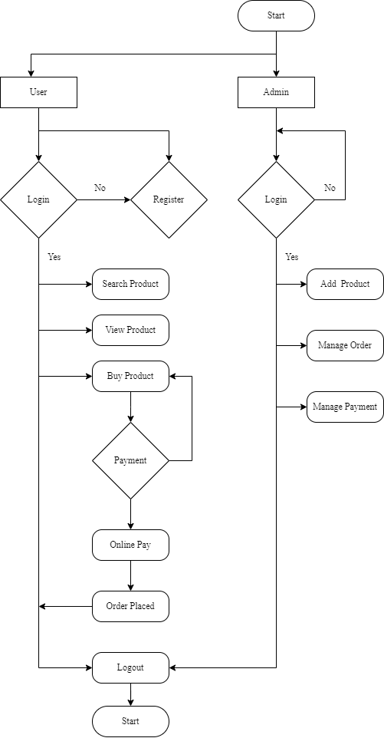Our approach to building the hiking and trekking equipment e-commerce website is focused on building a stable and intuitive platform that allows hikers and trekkers to effectively handle a variety of gear and items categorized into different categories guarantee a smooth and simple user experience. Flow chart is show in diagram below:

The Trekking E-commerce proceeds in a logical flow, with the user entering their email address and password to log in or Register. After that, a dashboard with a variety of items to select from and purchase along with other features is shown to them. The major functions are shown below:

### User Function

1. **Login or Register**

Using their password and email address, users may log in. They must first register for an account. Similarly, administrators have a unique login feature.

1. **Main Dashboard**

The user is shown a dashboard with a range of items that are divided into categories for them to pick from and purchase after logging in.

1. **Search Function**

The user's search feature can also be used to look up necessary products.

1. **Payment**

Following their selection of a product, the consumer is provided with a different interface that includes an online payment option.

### Admin Function

1. **Adding and Removing Products**

Administrators have the ability to add new goods, categorize them, and remove existing trekking products and gears.

1. **Checking User Information**

Admins have the ability to view a user’s email address for login, monitor their activity, and delete their credentials from the web application.

1. **Payment**

Administrators have the ability to validate user payments and ensure that the product have been sold.

## Methodology of the proposed system

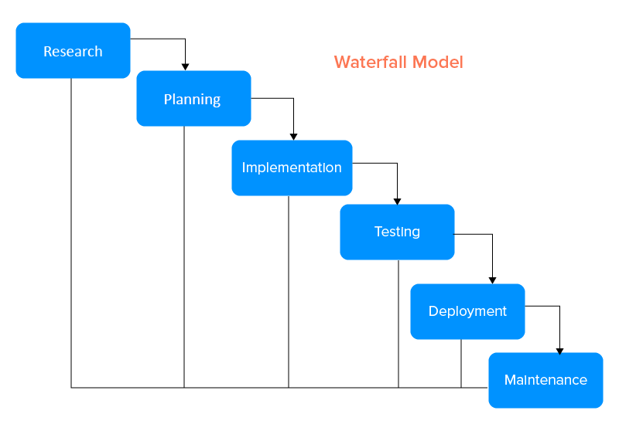When developing the website, we'll follow the waterfall Model. Because this project has clear objectives, detailed documentation, and well-understood technology, so waterfall model is best suited.

1. **Discovery and Research:**

We will conduct a comprehensive market analysis to understand the specific needs and preferences of the Nepali outdoor community. Engage in user surveys to gather insights on local expectations and cultural nuances.

1. **Planning:**

Define project goals and objectives based on research findings. Develop a detailed project plan outlining tasks, timelines, and milestones. Establish the technology stack, considering local infrastructure and preferences.

1. **Implementation:**

We want to incorporate many interfaces, category-separated products, and an easily adaptable payment mechanism in a very user-friendly and responsive manner

1. **Testing:**

Our website will undergo comprehensive testing to ensure functioning, performance and address any issues that may arise.

1. **Deployment:**

Following testing, we will launch our e-commerce website with all of its features, products, a payment system and function of Creating, Reading, Updating and deleting (CRUD) of various hiking and trekking products.

1. **Maintenance:**

Lastly, we will compile user comments and criticism, make necessary improvements to the hiking e-commerce website, and add new items.

## Working Mechanism of Proposed System

The trekking e-commerce website serves as a central hub for hikers and trekkers to select from a wide range of products to go along with their travels and journey. As such, it will feature a safe login process, smooth navigation, and an extremely safe payment system to ensure user satisfaction.

**User Interface:**

The user interface for browsing Products and items in an eye-catching and engaging online application will be created using CSS and HTML.

**Data Handling:**

The user credentials as well as variety of products will be stored in PHP MySql for convenience, security, and simple access.

**CRUD Function:**

The user interface is used to carry out activities, making it possible to add, update, and remove products.

**Security:**

The security elements provide the highest level of protection for the payment and login processes.

## Gantt chart

|  |  |  |  |  |  |  |  |  |  |  |
| --- | --- | --- | --- | --- | --- | --- | --- | --- | --- | --- |
| Weeks | 1-2 | 2-4 | 4-6 | 6-8 | 8-10 | 10-12 | 12-14 | 14-16 | 16-18 | 18-20 |
| Planning |  |  |  |  |  |  |  |  |  |  |
| Analysis |  |  |  |  |  |  |  |  |  |  |
| Design |  |  |  |  |  |  |  |  |  |  |
| Coding |  |  |  |  |  |  |  |  |  |  |
| Testing |  |  |  |  |  |  |  |  |  |  |
| Delivery |  |  |  |  |  |  |  |  |  |  |

## Expected Outcome

**Cultural and Local Engagement:**

* A focus on using carefully chosen trekking experiences to promote and protect Nepal's rich cultural and ecological heritage.
* Partnerships with regional companies and craftsmen to market and sell genuine Nepalese goods in addition to hiking equipment.

**Community Involvement:**

* Contribution to local communities through sustainable tourism practices.
* Support for community projects and initiatives that benefit the regions where trekking activities take place.

**Participation in Tourism Promotion:**

* Involvement in events and campaigns that promote Nepal as a trekking destination.
* Encouraging and showcasing positive customer experiences through reviews and testimonials.
* Continuous improvement based on customer feedback to enhance the overall trekking experience.

## Reference

1. google.com
2. openai.com/chatgpt
3. bcanotesnepal.com
4. trekkinggearnepal.com
5. breathenepaltrekking.com